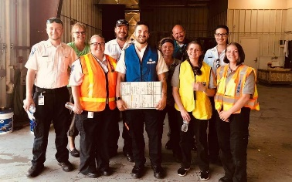Andrew Berkey, NRP

Andrew Berkey is originally from Morris Minnesota where he started his EMS career with Stevens County Ambulance in 2014. He quickly became involved in EMS Education at the EMT level and took over the education program in 2016. From there he took on numerous roles for the ambulance service, which included a position termed “community outreach specialist” which included public education and engagement. Andrew completed his Paramedic in 2016 in Jamestown ND. He accepted the Operations Manager position in May of 2018. Since then, he and his team has worked very hard at continuing to build a positive relationship in the Jamestown community that both engaged its citizens and also educated them on the importance of EMS. Andrew has a 4 year old daughter named Thea and they love to spend time around the fire, read stories, go to the park, kayak, and have tea parties together. Andrew may be the boss at Jamestown Ambulance, but that dynamic changes as soon as the kid gets home.

Engen for 38 years and has 3 children and 6 grandchildren. His hobbies are hunting, meat processing, outdoor cooking, and camping.

 Neil Frame, NRP

Operations Director – Metro Area Ambulance Service,

Metro Billing Services, Bismarck Air Medical

Neil began his career in EMS with the Mohall Ambulance Service obtaining his EMT in 1991. Neil was accepted into the Medcenter One Paramedic Program in Bismarck and

obtained his Paramedic certification in July of 1993. He started working for Metro-Area Ambulance Service that same month. Neil currently holds the position of Operations Director for the service focusing on billing and reimbursement issues, compliance, and the day to day operations of the ambulance and billing services. Neil has been active in EMS and is a former ND EVOC instructor, ND EMS instructor and NDEMSA board member.

A person wearing a suit and tie smiling at the camera

Description generated with very high confidence

Scott Moore, Esq.

Scott A. Moore, Esq. has been in the emergency medical services field for nearly 30 years. Scott has held various executive positions, including Chief Executive Officer, Vice President, Director of Human Resources, & Director of Operations, and field level provider at several ambulance services in Massachusetts. Scott is a licensed attorney, specializing in Human Resources, employment and labor law, employee benefits, ambulance service reimbursement, and corporate compliance matters. Scott is the Human Resources & Operational Consultant to the American Ambulance Association (AAA) and frequently lectures at EMS conferences.

Scott is the owner of Moore EMS Consulting, LLC, which has been providing Human Resources, Revenue Cycle Management, and Employment Law services since August 2015. Scott’s principal client is the American Ambulance Association (AAA) which is the trade association representing EMS agencies in the United States. In addition to the AAA, Scott exclusively represents EMS and Home Health clients.

Scott holds certifications as a Professional in Human Resources (PHR), Society for Human Resources Certified Professional (SHRM-CP), and Certified Ambulance Compliance Officer (CACO). In addition, Scott has been a Site Reviewer for the Commission on the Accreditation of Ambulance Services (CAAS) for many years. Scott earned his bachelor’s degree in Psychology from Salem State College and his Juris Doctor from Suffolk University Law School. Scott maintains his EMT and still works actively in the field as a call-firefighter/EMT in his hometown. Scott is a member of the American Bar Association, the Massachusetts Bar Association, the Society for Human Resource Management, and the Northeast Human Resource Association.

Lindsey Narloch, MS

Originally from Ray, Lindsey was raised to always look for ways to help. With help in mind, Lindsey earned a Bachelor of Science in Sociology and Emergency Management from North Dakota State University (NDSU), a Master of Science in Emergency Management (NDSU), and a Master Certificate in Performance Improvement from the University of Minnesota School of Public Health.

In her ten years at the Division of Emergency Medical Systems for the North Dakota Department of Health, she came to love the people and systems that bring care to every part of North Dakota. Lindsey was very active with that National Association of State EMS Officials (NASEMSO) Data Council. NASEMSO’s role is to work with states to advocate for and create consistent EMS systems. She served as the Secretary, Chair-Elect and Chair of the council.

Through her work in national data initiatives, Lindsey was chosen for the EMS Compass Steering Committee. The goal of EMS Compass Project was to help EMS systems measure and improve the quality of care at the local, regional, state and national levels by engaging a wide range of EMS stakeholders to develop performance measures that are relevant to EMS agencies, regulators, and patients.

Currently, Lindsey is the project manager for the Rural EMS Counts project. The project is funded by the Center for Rural Health through the Flex grant program from HRSA and looks to implement a set of rural-relevant EMS performance measures.

Lindsey lives in Bismarck with her husband (Brett), her two children (Harper and Hudson) and dog (Freddy).

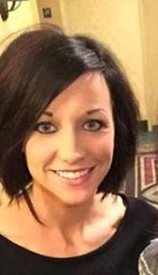 PJ Ringdahl, NRP

PJ Ringdahl is a paramedic and Administrative Director with Ringdahl EMS – North Dakota.  She began her EMS career in 2005; upon completion of her EMT she began working part-time as an EMT for Jamestown Area Ambulance while attending Valley City State University, majoring in Elementary Education.  In 2009, PJ became a NREMT-Intermediate and continued her fulltime employment with Jamestown Area Ambulance.  PJ started teaching EMR, EMT-B and CPR classes in 2010 and grew to love educating others.  After two years working as an Intermediate, PJ decided to take a different route in EMS by accepting the BLS Education Coordinator position with Emergency Training Associates. PJ has a passion for educating members of her community and the surrounding communities on the importance of early CPR and immediate defibrillation.  In 2012, PJ became a Nationally Registered Paramedic; and began educating at the ALS level.

PJ is married and has two sons, Cole (17 years old) and Cullen (10 years old). She enjoys watching her children’s sporting events (baseball and hockey), fishing, and traveling with her husband.

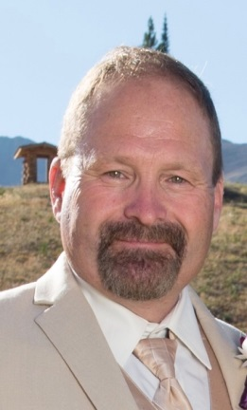 Daniel Schaefer, NRP

|  |
| --- |
| Daniel Schaefer started his emergency medical career by volunteering on a local rural ambulance service in 1985 and, in 1993, he began his professional EMS career by completed his paramedic training at Medcenter One Emergency Care Education System in Bismarck, ND. Dan has been employed by Metro Area Ambulance Service since 1994 as a National Registry Emergency Medical Paramedic and is currently the Operations Chief. Dan studied business administration at the University of Mary and has successfully completed training at the FEMA Noble Training Center in Anniston for Emergency Preparedness, Incident Management/Unified Command and WMD incident Command Training. Dan frequently provides Incident Command System training and is on the North Dakota IMAT Team. Dan has completed training in Emergency Medical Dispatch as well as completed an EMS expert course by North Central EMS Institute.  Dan grew up on a dairy farm in southwest North Dakota. That rural life instilled a love for the outdoors. Even while enjoying the outdoors, Dan is involved with life safety. Dan provides volunteer emergency medical care as an OEC provider (Outdoor Emergency Care) as a member of the Huff Hills Ski Patrol south of Mandan, ND. Dan the OEC instructor trainer. Dan has completed courses in Avalanche safety and Mountain Travel and Rescue. Dan also is an OEC advisor for the Northern Division of the National Ski Patrol that takes him to Wyoming and Montana routinely to work with others who believe like he does that volunteerism is one of the key strengths to any community. |

 Mona Thompson, NRP

Mona has been actively involved in EMS since 1991 and currently serves as the EMS Director for Kidder County Ambulance as well as a NR-Paramedic and EMS/AHA Instructor. Her past EMS experience includes the position of Regional Advisor for NDEMSA and Safe Tech Solutions, Simulation Instructor for Sanford Health and EMS/AHA Instructor for Medcenter One EMS Education. She has taken a special interest with PTSD in EMS Providers, and currently chairs the Mental Wellness Committee with NDEMSA. Mona lives with her husband, 2 sons, Golden Retriever, and too many cats on a hobby farm in Steele, ND and relieves her stress with gardening, fishing, kayaking, and camping with her family!