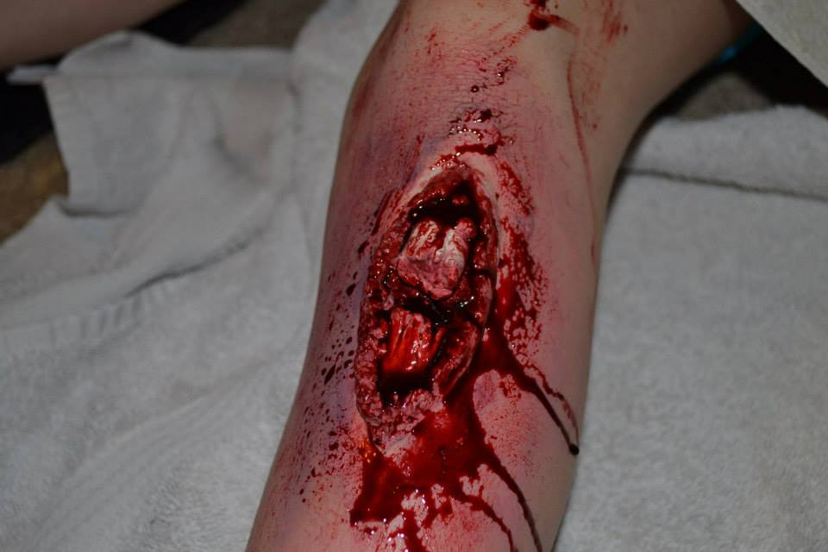  Oct. 19th  MOULAGE MAKEUP  Create mind blowing special effects  Ever wanted to create lifelike makeup for training? Ever wanted to learn how to do makeup like the Pro’s in your favorite movies and TV shows? Want to scare the life out of your friends this Halloween? If you said Yes then this class is for you.  Join us for an amazing 8 hours of makeup fun where you will learn the basics of moulage special effects makeup.  COST- $200.00 – Includes Student Kit  Location- Metro Ambulance Bismarck - 1139 Memorial Hwy, Bismarck, ND 58501  For Registration please contact Christopher South at medic4oil@yahoo.com or 701-340-4925  Last day to register is October 4th! Limited seating | Each student gets their own makeup kit!  ────  Learn form a Pro-Card Special Effects artist and Paramedic  ────  Create burns, bruises, broken limbs and other injuries  ────  Learn techniques to make cool Halloween makeup like Zombies  ────  Step up your training with awesome make-up  701-340-4925  Web Address  Dates and Times

